Contexte Banque HHB

Question 1:

Le compte peut avoir zéro ou plusieurs opération qui sont faites et les opérations concernent un ou plusieurs comptes

Question 2:

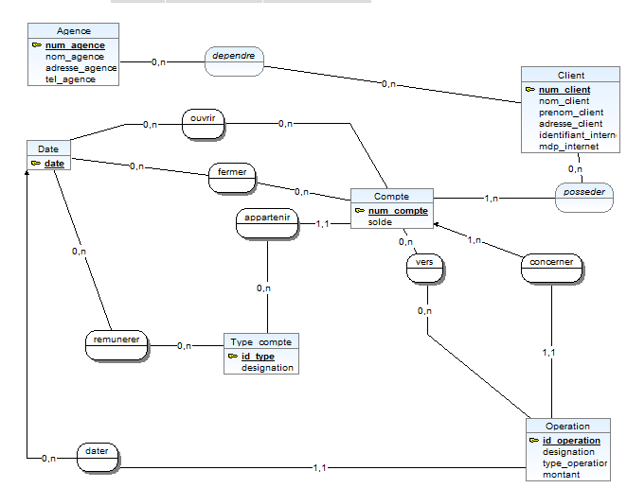

Question 6 :

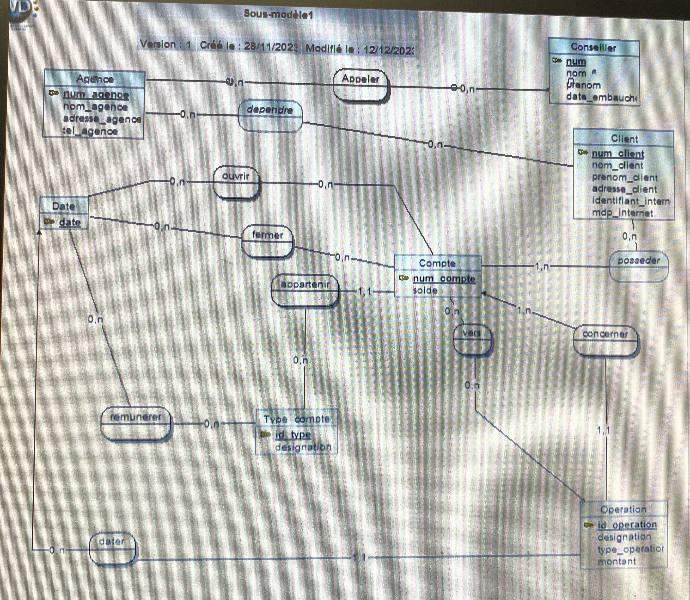

Question 10: CREATE TABLE Compte (
num_compte INT PRIMARY KEY
solde DECIMAL(10, 2) DEFAULT 0.00
);
Question 11:CREATE TABLE posseder (
id_personne INT,
id_objet INT,
PRIMARY KEY (id_personne, id_objet),
FOREIGN KEY (id_personne) REFERENCES Personne(id_personne),
FOREIGN KEY (id_objet) REFERENCES Objet(id_objet) ) ;
Question 12: SELECT ‘client’, ‘nom’,’prenom’,solde’ FROM TABLE
Question 13: SELECT * FROM ‘Compte’ AND ‘SOLDE’
GROUP BY
Question 14 :SELECT
client_id,
COUNT(*) AS nombre_operations_credit
FROM
operations
WHERE
type_operation = 'CREDIT'
AND EXTRACT(YEAR_MONTH FROM date_operation) = 202008
GROUP BY
client_id;

Question 14: SELECT
c.num_client,
c.nom,
c.prenom,
COUNT(o.id_operation) AS nombre_operations_credit
FROM
Client c
JOIN
posseder p ON c.num_client = p.num_client
JOIN
Compte co ON p.num_compte = co.num_compte
JOIN
Operation o ON co.num_compte = o.num_compte
WHERE
MONTH(o.date_operation) = 8 AND YEAR(o.date_operation) = 2020
AND o.type_operation = 'CREDIT'
GROUP BY
c.id_client, c.nom, c.prenom;

Question 15: SELECT
c.num_client,
c.nom,
c.prenom,
SUM(co.solde) AS solde_total
FROM
Client c
JOIN
posseder p ON c.num_client = p.num_client
JOIN
Compte co ON p.num_compte = co.num_compte
GROUP BY
c.id_client, c.nom, c.prenom
HAVING
SUM(co.solde) > 20000;

